
File System Navigator User Manual


Authors:
- Jawad Ahmed
- Fida Hussain
- Shahzeb Azeem

1. Introduction
FileSystemNavigator is a console-based Java application that simulates a basic file system. It allows users to create, navigate, and manage folders and files using a menu-driven interface.
This user manual explains how to use each feature, what input is required, and what output to expect.

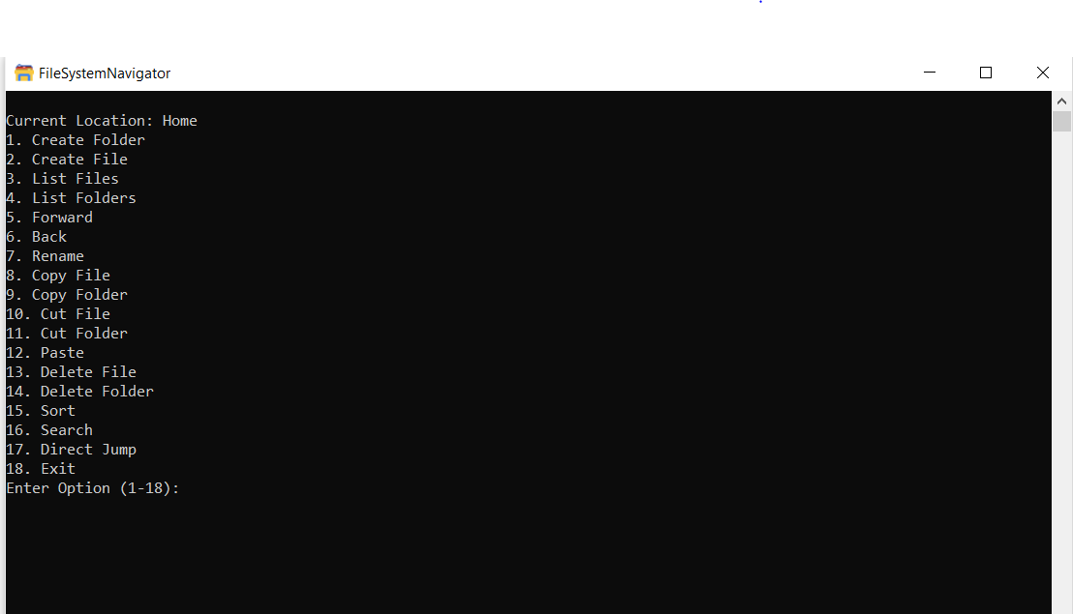
2. Starting the Application

3. Main Menu Overview
The above menu appears on every iteration:
- Capture full menu list
- Ensure current path is visible

4. Feature-wise Usage Guide

4.1 Create Folder
Purpose: Creates a new folder in the current directory.
Steps:
- Select option 1
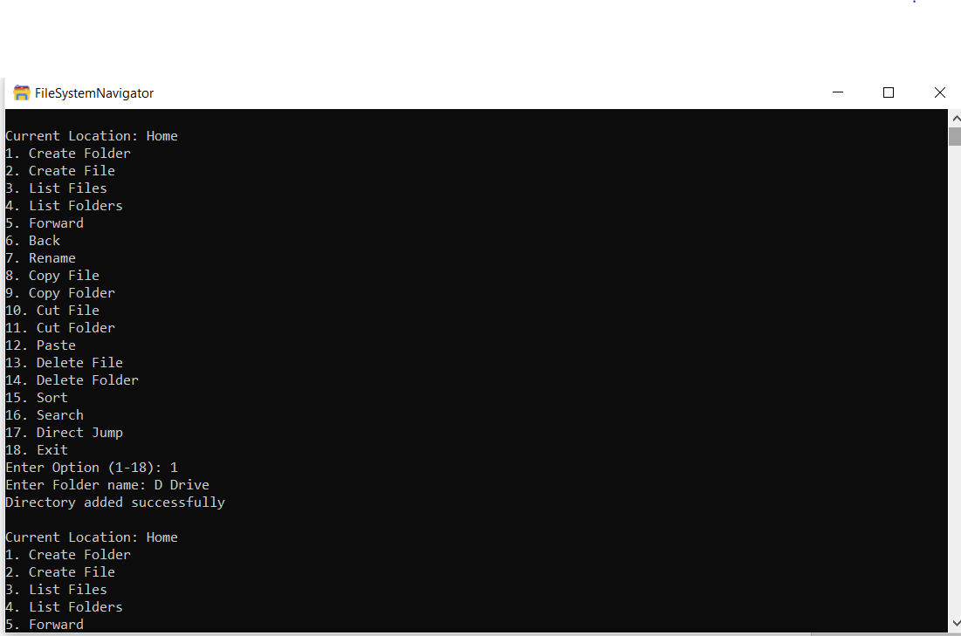
- Enter folder name

4.2 Create File
Purpose: Creates a new file in the current directory.
Steps:
- Select option 2
- Enter file name
Same as Creating Folder.
Note: The File and Folder with same file can reside in a root Folder but not two same name files or two duplicate folders.

4.3 List Files
Purpose: Displays all files in the current directory.
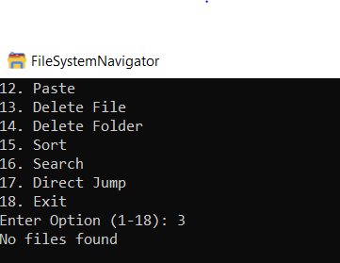
Steps:
- Select option 3

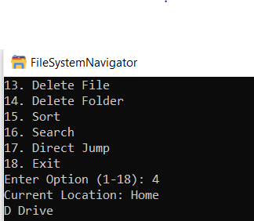
4.4 List Folders
Purpose: Displays all subfolders in the current directory.
Steps:
- Select option 4

4.5 Forward (Navigate Into Folder)
Purpose: Moves into a selected subdirectory.
Steps:
- Select option 5
- Enter folder name
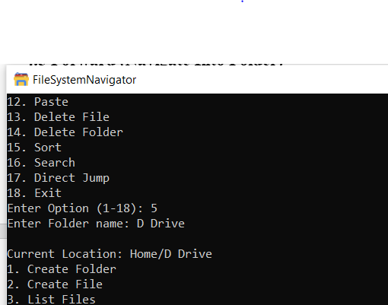

4.6 Back (Navigate to Parent Directory)
Purpose: Moves back to the parent directory.
Steps:
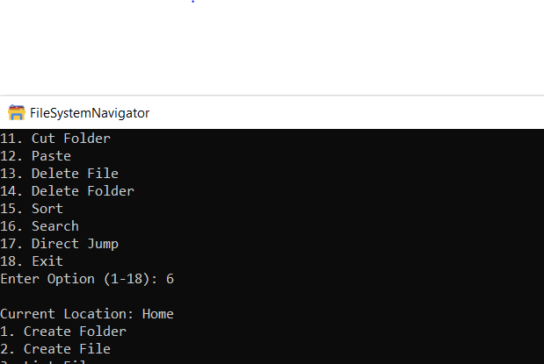
- Select option 6

4.7 Rename File or Folder
Purpose: Renames an existing file or directory.
Steps:
- Select option 7
- Enter current name
- Enter new name
- Choose:
  - 1 for File
  - 2 for Folder
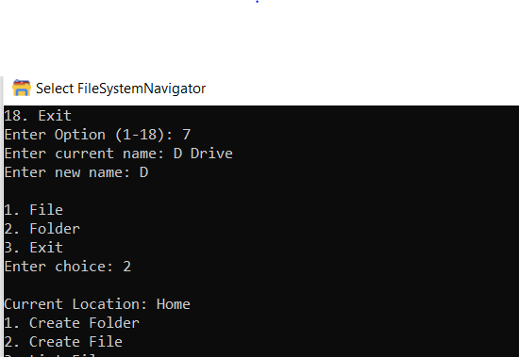

Now, when you list folders you will see the “D Drive” name changed to “D”

4.8 Copy File / Folder
Purpose: Copies a file or folder for pasting later.
Steps:
- File: Option 8
- Folder: Option 9
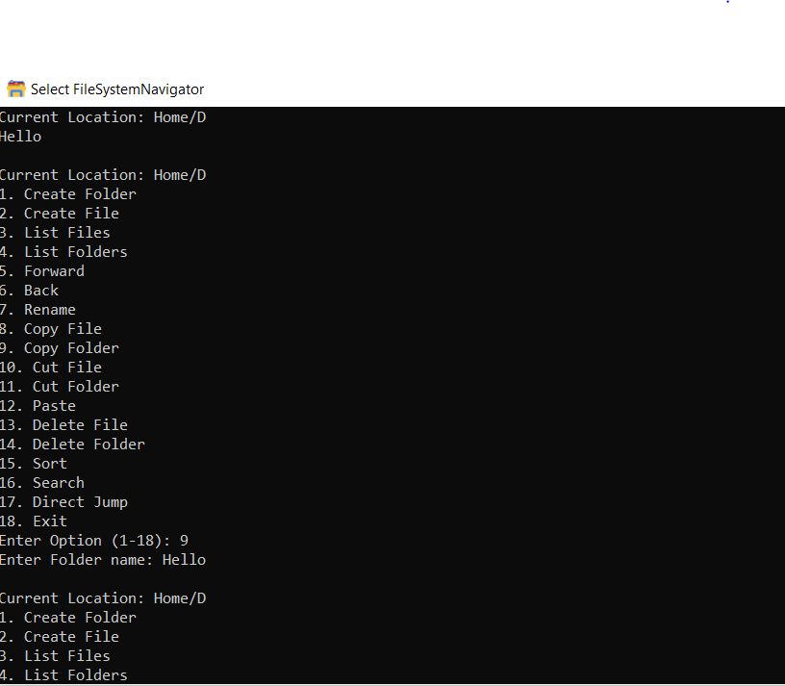

4.9 Cut File / Folder
Purpose: Cuts (moves) a file or folder.
Steps:
- File: Option 10
- Folder: Option 11
Same as the Copy operation shown above

4.10 Paste
Purpose: Pastes copied or cut item into the current directory.
Steps:
- Navigate to destination
- Select option 12
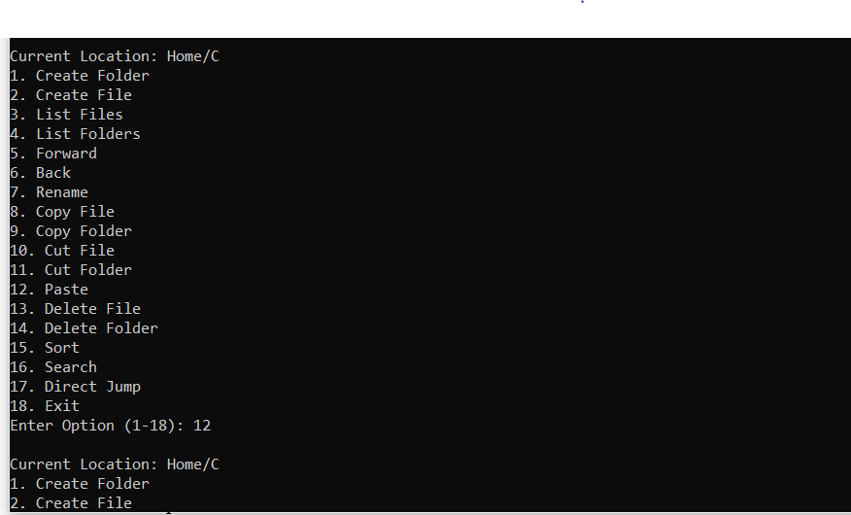

4.11 Delete File / Folder
Purpose: Permanently deletes a file or folder.
Steps:
- File: Option 13
- Folder: Option 14
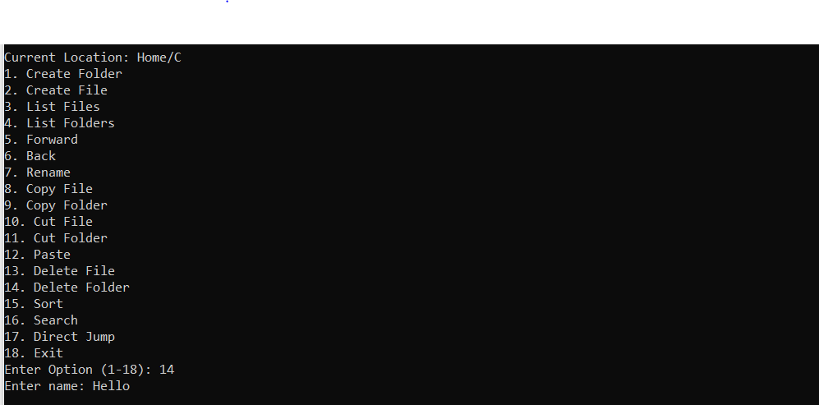

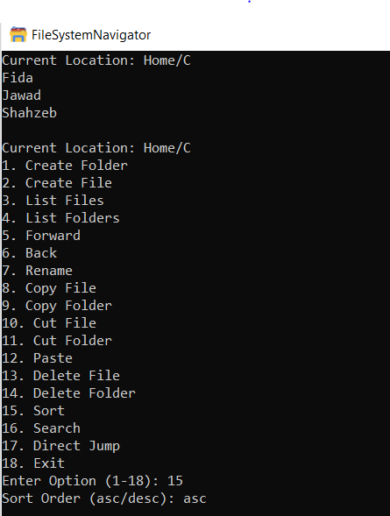
4.12 Sort Files and Folders
Figure 1 Before sort folders
Purpose: Sorts contents alphabetically.
Steps:
- Select option 15
- Enter asc or desc

After Sort the Folders will be (see the result through list folders/files):
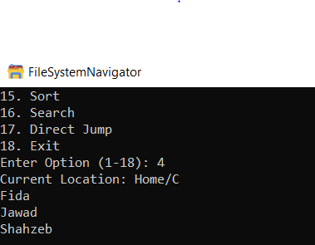

4.13 Search
Purpose: Searches for a file or folder starting from Home.
Steps:
- Select option 16
- Enter name
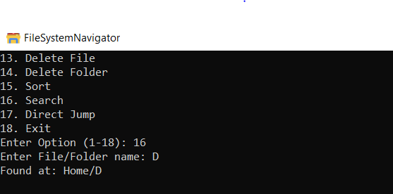
📸 Screenshot 15 – Search Result

Now you have the path of the required directory and so you can navigate to the destination directory.

4.14 Direct Jump
Purpose: Jumps directly to a specific path.
Steps:
- Select option 17
- Enter full path (e.g., Home/Documents)
From any location you can jump to any existing location (Directory)
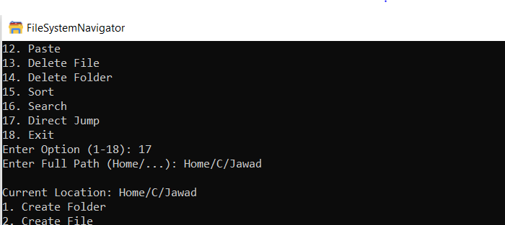

6. Known Limitations
- No data persistence after exit
- Console-based UI only
- Case-insensitive names

7. Exit
Select option 18 to exit the application safely.

